IDEATION PHASE

DEFINE THE PROBLEM STATEMENT

|  |  |
| --- | --- |
| DATE | 21 October 2022 |
| TEAM ID | PNT2022TMID23850 |
| PROJECT NAME | IOT BASED SMART CROP PROTECTION SYSTEM FOR AGRICULTURE |
| MAXIMUM MARKS | 2 |

# PROBLEM STATEMENT

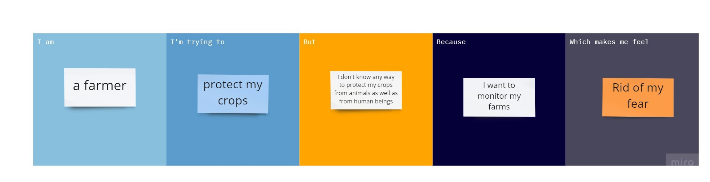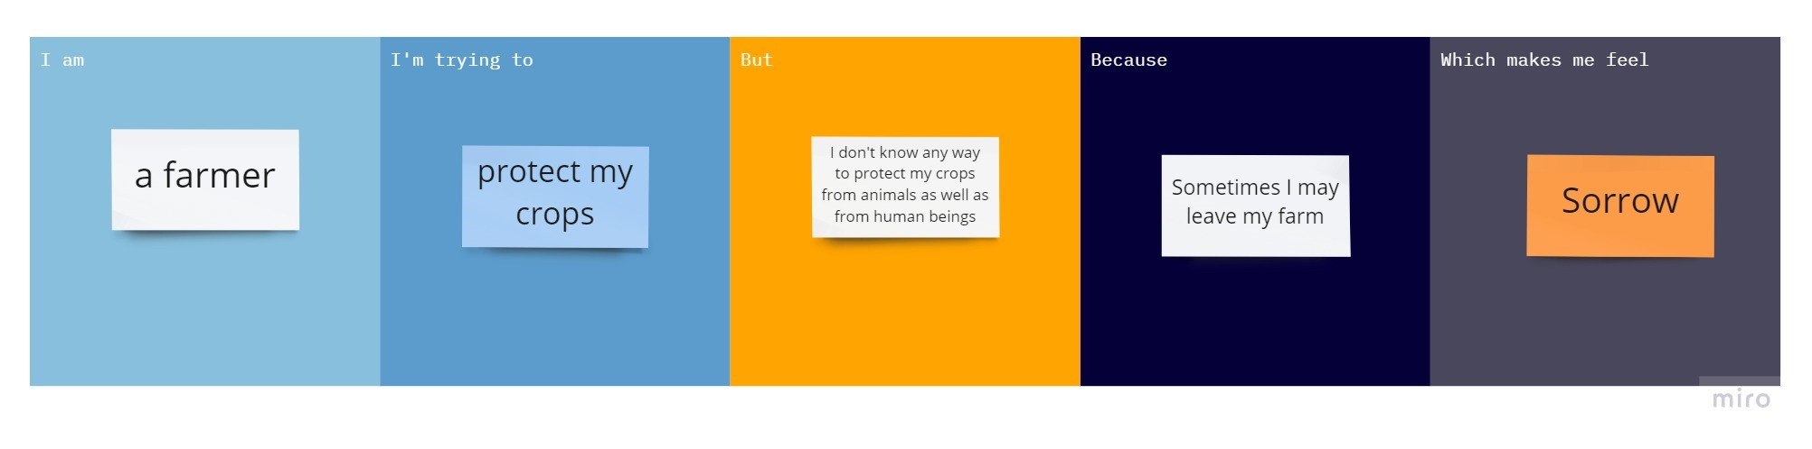

|  |  |  |  |  |  |
| --- | --- | --- | --- | --- | --- |
| PROBLEM  STATEMENTS(PS) | I AM  (CUSTOMER) | I AM  TRYING TO | BUT | BECAUSE | WHICH  MAKES ME  FEEL |
| PS-I | FARMER | PROTECT MY CROPS | I DON’T  KNOW ANY  WAY TO  PROTECT  MY CROPS  FROM  ANIMALS  AS WELL AS  FRON  HUMAN  BEINGS | I WANT TO  MONITOR  MY FARM | RID OF MY FEAR |
| PS-II | FARMER | PROTECT MY CROPS | I DON’T  KNOW ANY  WAY TO  PROTECT  MY CROPS  FROM  ANIMALS  AS WELL AS  FRON  HUMAN  BEINGS | SOMETIMES  I MAY LEAVE MY FARM | SORROW |